# X:\The Sound Shared\LOGOS\Sound Logos\Stacked-full-color.jpg

# Permitted Items

 **Bag Policy**

Clear bags not to exceed 12” x 6” x 12” OR small clutch bags 4.5" x 6.5" (roughly the size of an index card) that can fit in your pocket. No other bags of any type will be allowed.

**Diaper Bags & Medical Equipment**

Diaper bags accompanying a small child or bags containing medical equipment are subject to screening

**Blankets and Towels**

Blankets and towels that do not exceed 30" x 60"

## Prohibited Items

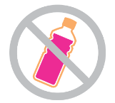**Outside Containers**

Glass or plastic bottles, cans, thermoses or hard sided containers of any size or styles

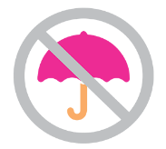**Umbrellas**

Umbrellas are not allowed in the venue.

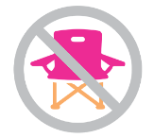**Outside Chairs**

Chairs, portable seating and seat cushions with pockets, arms, backs or zippers.

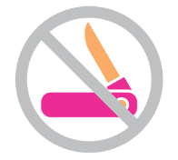**Weapons or Hazardous Items**

(i.e. mace, pocket knives, chains, spikes)

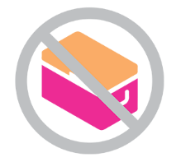**Coolers**

In addition to hard sided containers/bottles and outside food & beverages

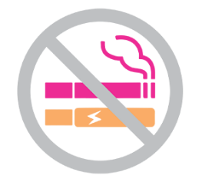**Smoking or Vaping**

**Prohibited Items include:**

* Illegal drugs
* Weapons of any kind, including mace
* Pocket knives
* Outside coolers or hard sided containers/bottles of any kind
* Lawn chairs of any kind
* Air sofas or inflatable loungers
* Backpacks, luggage, totes or other bags exceeding the maximum requirements
* Outside food and beverages
* Aerosols (e.g. Sunscreen, hairspray)
* Personal property that is a potential hazard to others (e.g. chains, wallet chains, or jewelry with spike edges)
* Fireworks
* GoPro cameras
* Tripods, monopods, selfie-sticks
* Lasers, glow sticks, air horns, noise makers
* Confetti, glitter and other items that can be thrown
* Totems
* Staffs Inc. dragon staffs/glow staffs, whips inc. pixel/space whips
* Audio/video recording devices
* Remote controlled flying devices or drones
* Props or toys that resemble weapons
* Unauthorized vending of any kind
* Unauthorized solicitations, handbills, sampling, giveaways, etc.
* Balloons
* Frisbees, Beach Balls
* Strollers
* Umbrellas
* Hover-boards
* Tents
* Glass or plastic bottles, cans, thermoses or hard sided containers of any size or style
* Animals (excluding service animals fitting requirements)
* Smoking or vaping
* Other items at the discretion of security

**Permitted Items specific to The BayCare Sound:**

* Clear bags not to exceed 12” x 6” x 12” OR small clutch bags (4.5" x 6.5" - roughtly the size of an index card)
* Diaper bags accompanying a small child or bags containing medical equipment, subject to screening
* Blanket and beach towels that do not exceed 30" x 60"
* Empty, clear camelback/hydration packs that do not exceed 12” x 6” x 12”

|  |  |
| --- | --- |
| Cashless Venue (800 × 800 px).png | **WE ARE A CASHLESS VENUE** The venue is cashless. All points of sale will only accept payment via all major credit cards. Reverse ATMs/Cash-to-card machines are located nearby and allow you to deposit cash and dispense a charge card to be utilized on-site and can also be accepted anywhere that takes Visa/MasterCard.  For more information on available concessions and food trucks, [visit here](https://www.rutheckerdhall.com/plan-your-visit/the-sound-2/concessions-food-trucks/). |

For your safety and those around you, we appreciate your cooperation with our security personnel and compliance with Ruth Eckerd Hall’s safety protocols while attending events at The BayCare Sound.

For more information, please visit:

<https://www.rutheckerdhall.com/baycare-sound>

<https://www.rutheckerdhall.com/permitted-and-prohibited-items>